Assignment 3_1
- How many vowels are there in the names of USA States?
States<- rownames(USArrests)
vowels<-c("a","e","i","o","u")
num_vowels = vector(mode = "integer", length = 5)
for (i in seq_along(vowels)) {
num_aux = str_count(tolower(States), vowels[i])
num_vowels[i] = sum(num_aux)
}
names(num_vowels) = vowels
num_vowels
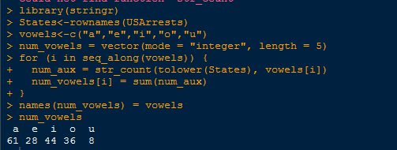
2. Visualize the vowels distribution.
barplot(num_vowels, main = "Number of vowels in USA States names",
border = NA, ylim = c(0, 80))
